Press Release
For Immediate Release
Contact: Erin Drennan 516-442-1590

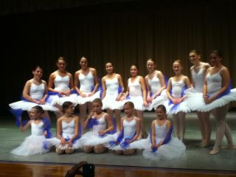
Local Ballet Students Perform Ballet's Greatest Ghost Stories on October 21st at the Brookside School
Advanced ballet students of Integral Ballet in Merrick performed excerpts from ballet's most cherished ghost stories, on October 21^{st.} The performance included new and original choreography of Giselle, La Bayadère and Les Sylphides.
Integral Ballet school’s in-house student ballet company, the FAITH Dance Project held their October 21st performance of excerpts from ballet’s most cherished ghost stories. The performance was entitled Ballet’s Greatest Ghost Stories and included new choreography based on the stories and scores of Giselle, La Bayadère and Les Sylphides. It featured the famous excerpt of choreography by Marius Petipa’s original Kingdom of Shades.
This was the company’s seventh season and seventh production. The company recently introduced a junior division and welcomed its two youngest dancers, Mikayla Marten and Becca Sirof, both of Merrick. Veteran dancers include soloists Sophia Casto, dancing as Giselle, Sabrina Cortor, Natalie Ferretti, Falyn Katzman as Myrtha, Lauren Levit, Alexandra Ronan and Jamie Speigel. New dancers in the senior ballet company include Jessica Bortolussi, Anna Byington, Natalie Floridia, Emily Koenig and Stephanie Pavlides. Each of the dancers has studied with FAITH Project and [Integral Ballet] Artistic Director, Erin Drennan, or Frank Ohman of [The Ohman School of Ballet].
The FAITH Project was established in 2005 to create a memorial donation fund to the American Lung Association in loving memory of Faith Florida, an alumnus of the Frank Ohman School of Ballet.

The performance of Ballet’s Greatest Ghost Stories raised hundreds of dollars for the NYS American Lung Association in her honor. Natalie Floridia, Faith’s youngest sibling performed for the first time with the youth company. The FAITH Dance Project and Integral Ballet have contributed over $5000 to the American Lung Association of NYS since beginning its mission in 2005 and its first performance in 2006.
Students of Integral Ballet may audition for a role in the FAITH Dance Project’s annual performance each year in January. Students also participate in performances throughout the year at local senior homes, street festivals and lecture/demonstrations. Integral Ballet is located at 1842 Merrick Road in Merrick. Call (516) 442-1590 for class, audition and booking information. For more information, visit www.integralballet.com.

###

