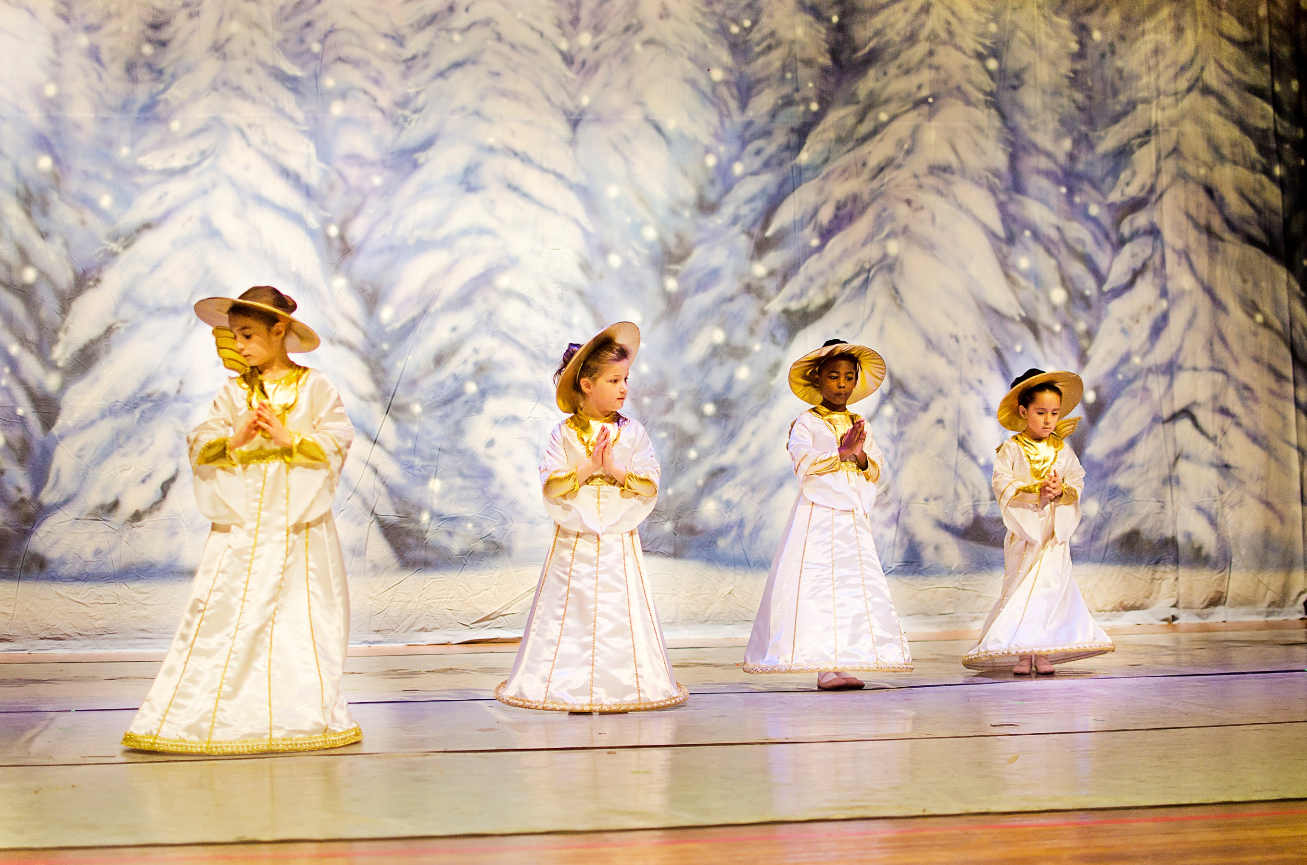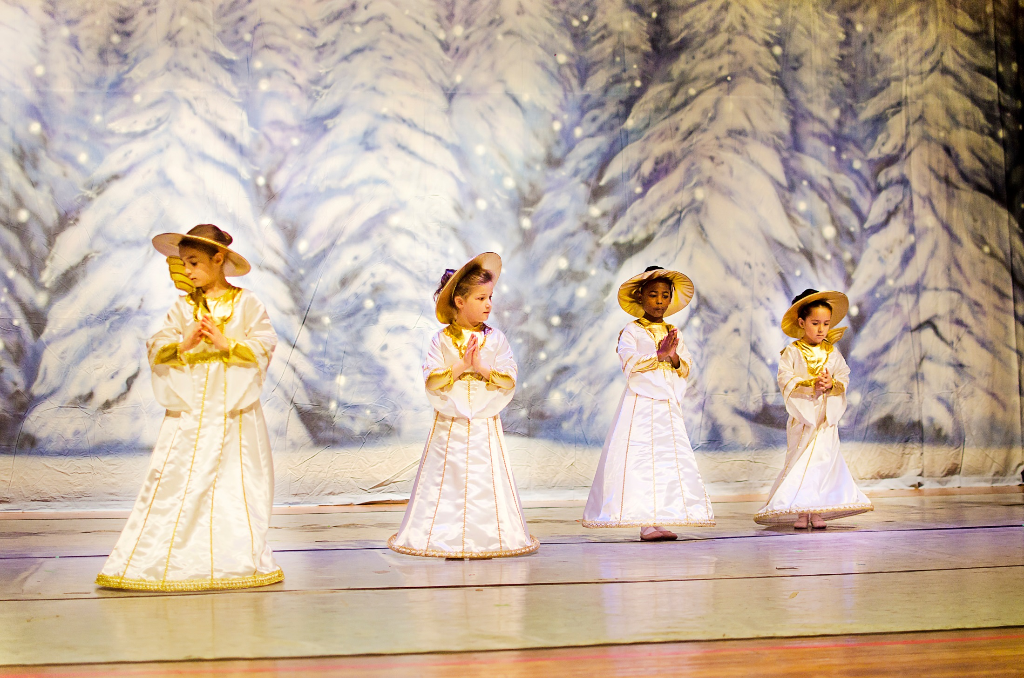C:\Users\Integral Ballet\AppData\Local\Microsoft\Windows\Temporary Internet Files\Content.IE5\YPJY1DFU\MC900336061[1].wmfC:\Users\Integral Ballet\AppData\Local\Microsoft\Windows\Temporary Internet Files\Content.IE5\YPJY1DFU\MC900336061[1].wmf

**General Admission $20**

**Tickets by phone or online…**

**(516) 442-1590 | integralballet.com**

A Merry Mini

**Sunday, November 30th**

**12pm & 5pm**

**Brookside School in Merrick**

Nutcracker